**EX 16: Two-Way-Binding**

Your task is to **collect the values** entered into the two input controls (<textarea> and <input>) via **two-way binding**.

In addition, you should **pass** the collected values via the appropriate props to the already existing Review component.

*Important: In this Udemy workspace, you must use React.useState() instead of just useState()!*

The final app should allow users to enter values and then see those entered values in the Review component which is output below the input components. It should look like this:

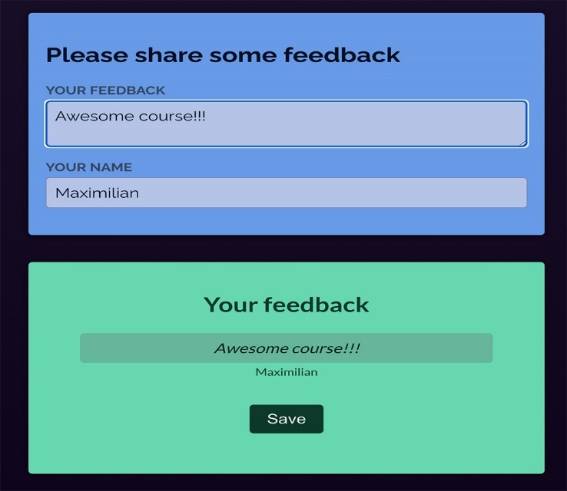

The "Save" button is just there for decoration purposes - you don't need to do anything with that!